|  |  |
| --- | --- |
| TEAM ID: | NM2023TMID04432 |
| PROJECT NAME: | AGRICULTURE DOCS CHAIN |

### MODEL PERFORMANCE METRICS

* In economic terms, demand refers to the amount of service or good that a consumer is willing and able to buy at a given price.
* We describe here demand as a right of farmers to get information and support from public extension services to attain their sustainable livelihood and quality life.
* Literature suggests that farmers need a breadth of information appropriate technology, optimal use of inputs, changing farm system options, input suppliers, intermediaries, quality specification, market and trade, time to buy inputs and sell produce, off farm generation options, implication of changing policy access to credit and loans etc.
* Moreover, Supply, refers to the extension services that are provided in response of farmers’ demand, mostly publically driven, facilitate farm households with scientific, technical, marketing and administrative information for a better decision making by farmer along the agri-supply chain.
* The broad view of agriculture extension is conceptualized in the framework that includes an interplay of Social system and Environmental system along with the Technical System as shown in [Figure 3](https://www.scirp.org/journal/paperinformation.aspx?paperid=92687#f3).
* The Technical System consists of the tools, techniques, artifacts, methods, configurations, procedures, and knowledge used by Extension Services driving actors/members to acquire inputs, transform inputs into outputs or services for consumers or beneficiaries.
* The Social System comprises of the people who are part of the system directly or indirectly and all that is human about their presence, such as attitudes, beliefs, relations, cultures, norms, politics, behaviors, and emotions.
* Community organization theory emphasizes on active participation and developing communities that can better evaluate and solve social problems .
* Environmental System is a connector between social and technical systems where a regulated relevant environment is created by Environment system that includes, government initiatives and support, policy and regulation, infrastructure, journalism & media, etc.
* The policy makers require to align conducive environment to pursue strategies, select resources, and implement technologies.
* Government initiatives and reforms can be evaluated in terms of efficiency, effectiveness and long term sustainability of provided service, quality level and level of farmers’ involvement.
* The performance measurement and improvement initiatives require decomposition of the supply (what is provided) and demand (what was expected) components of extension services.

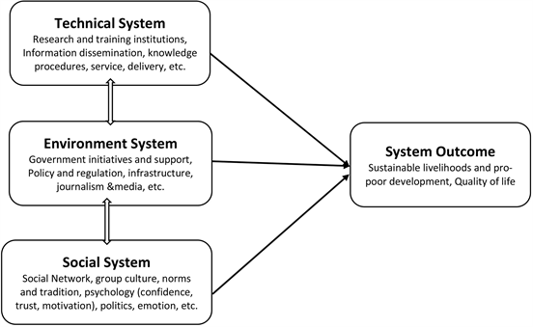

|  |  |
| --- | --- |
| [[1](https://www.scirp.org/reference/referencespapers.aspx?referenceid=2514864)] | Hegde, N.G. (2005) Traditional Extension Methods in Modern Agriculture. Indian Farming Special Issue on World Food Day, 45-47. |
| [[2](https://www.scirp.org/reference/referencespapers.aspx?referenceid=2514865)] | Bhusan, S. and Tirupati, D. (2013) System Dynamics Investigation of Capacity Building by Humanitarian Supply Chain in Disaster Prone Eco-Communities of India. Working Paper No. 416, Supply Chain Center, IIM, Bangalore.  https://doi.org/10.2139/ssrn.2303641 |
| [[3](https://www.scirp.org/reference/referencespapers.aspx?referenceid=2514866)] | Davis, K., Babu, S.C. and Sylvia, B. (2014) The Role of Extension and Advisory Services in Building Resilience of Smallholder Farmers. Building Resilience for Food and Nutrition Security, Addis Ababa, 15-17 May 2014, 2020 Resilience Conference Brief 13, 1-4. |